Deployment Report

AWS EC2 Instance type: T3 medium
Number of Instance: 1
REGION: Stockholm (eu-north-1)
CPU: 2
Memory: 4GB
Cost: 0.0583 USD per Hour (varies on region and demand)
Monthly Cost: 41.976 $ (varies on region and demand)
Yearly cost: 503$ (varies on region and demand)

Load test Performance:
Consideration: There were total 3000+ images in the vector DB.
If the number of images increase signaficantly, the performance will change too…Is expected to decrease by a little margin.
top5:
When retrieved top 5 elements each search, these were the result…
Here a simulation of 20 users were performed.
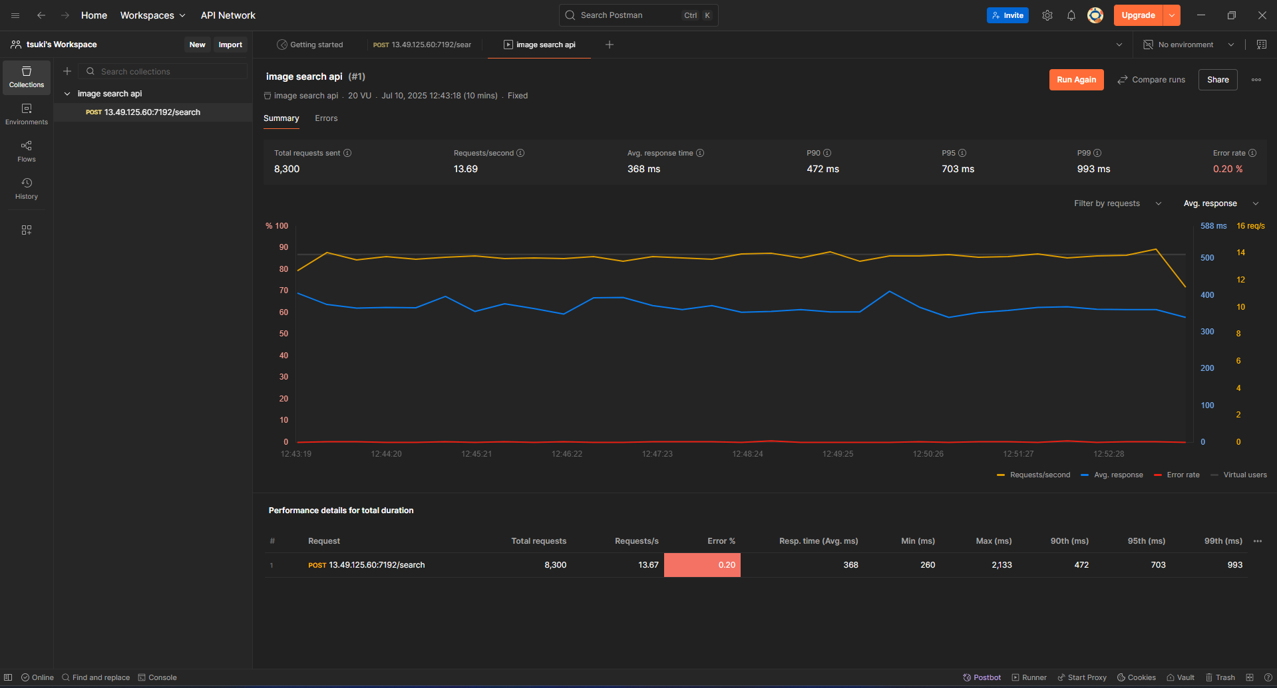
Top 500:
When retrieved top 500 elements each search, these were the result…
Here a simulation of 20 users were performed.

